Lab - Troubleshoot IPv4 and IPv6 Addressing Issues

# Topology

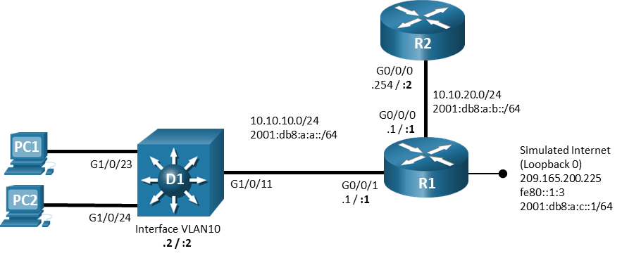

# Addressing Table

| Device | Interface | IPv4 Address/Mask | IPv6 Address/Prefix | IPv6 Link Local |
| --- | --- | --- | --- | --- |
| R1 | G0/0/0 | 10.10.20.1/24 | 2001:db8:a:b::1/64 | fe80::1:1 |
| R1 | G0/0/1 | 10.10.10.1/24 | 2001:db8:a:a::1/64 | fe80::1:2 |
| R1 | Lo0 | 209.165.200.225/29 | 2001:db8:a:c::1/64 | fe80::1:3 |
| R2 | G0/0/0 | 10.10.20.254/24 | 2001:db8:a:b::1/64 | fe80::2:1 |
| D1 | VLAN 10 | 10.10.10.2/24 | 2001:db8:a:a::2/64 | fe80::d1:1 |
| PC1 | NIC | DHCP | SLAAC | EUI-64 |
| PC2 | NIC | DHCP | SLAAC | EUI-64 |

# Objectives

Troubleshoot network issues related to IPv4 and IPv6 Addressing.

# Background / Scenario

In this topology, router R1 provides connectivity to a simulated internet for VLAN 10. R2 serves as a DHCP server. Switch D1 provides connectivity for VLAN 10. You will be loading configurations with intentional errors onto the network. Your tasks are to FIND the error(s), document your findings and the command(s) or method(s) used to fix them. FIX the issue(s) presented here and then test the network to ensure both of the following conditions are met:

* + - * 1. the complaint received in the ticket is resolved
        2. full reachability is restored

**Note**: The routers used with CCNP hands-on labs are Cisco 4221 with Cisco IOS XE Release 16.9.4 (universalk9 image). The switches used in the labs are Cisco Catalyst 3650 with Cisco IOS XE Release 16.9.4 (universalk9 image). Other routers, switches, and Cisco IOS versions can be used. Depending on the model and Cisco IOS version, the commands available and the output produced might vary from what is shown in the labs. Refer to the Router Interface Summary Table at the end of the lab for the correct interface identifiers.

**Note**: Make sure that the switches have been erased and have no startup configurations. If you are unsure, contact your instructor.

# Required Resources

* 2 Routers (Cisco 4221 with Cisco IOS XE Release 16.9.4 universal image or comparable)
* 1 Switch (Cisco 3560 with Cisco IOS XE Release 16.9.4 universal image or comparable)
* 2 PCs (Choice of operating system with terminal emulation program installed)
* Console cables to configure the Cisco IOS devices via the console ports
* Ethernet cables as shown in the topology

# Instructions

## Trouble Ticket 1.1.2.1

Scenario:

PC1 is unable to access resources on web server 209.165.200.225.

Use the commands listed below to load the configuration files for this trouble ticket:

|  |  |
| --- | --- |
| Device | Command |
| R1 | **copy flash:/enarsi/1.1.2.1-r1-config.txt run** |
| R2 | **copy flash:/enarsi/1.1.2.1-r2-config.txt run** |
| D1 | **copy flash:/enarsi/1.1.2.1-d1-config.txt run** |

* PC1 and PC2 should be configured for and receive an address from an IPv4 DHCP server.
* Passwords on all devices are **cisco12345**. If a username is required, use **admin**.
* When you have fixed the ticket, change the MOTD on EACH DEVICE using the following command:

**banner motd # This is $(hostname) FIXED from ticket <ticket number> #**

* Then save the configuration by issuing the **wri** command (on each device).
* Inform your instructor that you are ready for the next ticket.
* After the instructor approves your solution for this ticket, issue the **reset.now** privileged EXEC command**.** This script will clear your configurations and reload the devices.

## Trouble Ticket 1.1.2.2

Scenario:

PC1 and PC2 are unable to lease IPv4 addresses from the DHCP server.

Use the commands listed below to load the configuration files for this trouble ticket:

|  |  |
| --- | --- |
| Device | Command |
| R1 | **copy flash:/enarsi/1.1.2.2-r1-config.txt run** |
| R2 | **copy flash:/enarsi/1.1.2.2-r2-config.txt run** |
| D1 | **copy flash:/enarsi/1.1.2.2-d1-config.txt run** |

* PC1 and PC2 should be configured for and receive an address from an IPv4 DHCP server.
* Passwords on all devices are **cisco12345**. If a username is required, use **admin**.
* When you have fixed the ticket, change the MOTD on EACH DEVICE using the following command:

**banner motd # This is $(hostname) FIXED from ticket <ticket number> #**

* Then save the configuration by issuing the **wri** command (on each device).
* Inform your instructor that you are ready for the next ticket.
* After the instructor approves your solution for this ticket, issue the **reset.now** privileged EXEC command**.** This script will clear your configurations and reload the devices.

## Trouble Ticket 1.1.2.3

Scenario:

PC1 and PC2 are unable to resolve IPv6 addresses to hostnames. Upon investigation, it appears that they are not receiving DNS server information from the DHCPv6 server.

Use the commands listed below to load the configuration files for this trouble ticket:

|  |  |
| --- | --- |
| Device | Command |
| R1 | **copy flash:/enarsi/1.1.2.3-r1-config.txt run** |
| R2 | **copy flash:/enarsi/1.1.2.3-r2-config.txt run** |
| D1 | **copy flash:/enarsi/1.1.2.3-d1-config.txt run** |

* PC1 and PC2 should be configured to assign an address via SLAAC.
* Passwords on all devices are **cisco12345**. If a username is required, use **admin**.
* When you have fixed the ticket, change the MOTD on EACH DEVICE using the following command:

**banner motd # This is $(hostname) FIXED from ticket <ticket number> #**

* Then save the configuration by issuing the **wri** command (on each device).
* Inform your instructor that you are ready for the next ticket.
* After the instructor approves your solution for this ticket, issue the **reset.now** privileged EXEC command**.** This script will clear your configurations and reload the devices.

# Router Interface Summary Table

| Router Model | Ethernet Interface #1 | Ethernet Interface #2 | Serial Interface #1 | Serial Interface #2 |
| --- | --- | --- | --- | --- |
| 1800 | Fast Ethernet 0/0 (F0/0) | Fast Ethernet 0/1 (F0/1) | Serial 0/0/0 (S0/0/0) | Serial 0/0/1 (S0/0/1) |
| 1900 | Gigabit Ethernet 0/0 (G0/0) | Gigabit Ethernet 0/1 (G0/1) | Serial 0/0/0 (S0/0/0) | Serial 0/0/1 (S0/0/1) |
| 2801 | Fast Ethernet 0/0 (F0/0) | Fast Ethernet 0/1 (F0/1) | Serial 0/1/0 (S0/1/0) | Serial 0/1/1 (S0/1/1) |
| 2811 | Fast Ethernet 0/0 (F0/0) | Fast Ethernet 0/1 (F0/1) | Serial 0/0/0 (S0/0/0) | Serial 0/0/1 (S0/0/1) |
| 2900 | Gigabit Ethernet 0/0 (G0/0) | Gigabit Ethernet 0/1 (G0/1) | Serial 0/0/0 (S0/0/0) | Serial 0/0/1 (S0/0/1) |
| 4221 | Gigabit Ethernet 0/0/0 (G0/0/0) | Gigabit Ethernet 0/0/1 (G0/0/1) | Serial 0/1/0 (S0/1/0) | Serial 0/1/1 (S0/1/1) |
| 4300 | Gigabit Ethernet 0/0/0 (G0/0/0) | Gigabit Ethernet 0/0/1 (G0/0/1) | Serial 0/1/0 (S0/1/0) | Serial 0/1/1 (S0/1/1) |

**Note**: To find out how the router is configured, look at the interfaces to identify the type of router and how many interfaces the router has. There is no way to effectively list all the combinations of configurations for each router class. This table includes identifiers for the possible combinations of Ethernet and Serial interfaces in the device. The table does not include any other type of interface, even though a specific router may contain one. An example of this might be an ISDN BRI interface. The string in parenthesis is the legal abbreviation that can be used in Cisco IOS commands to represent the interface.

End of document